1.Create an Author component which will have 3 fields

Author Name-single line text field-Mandetry

Author Bio-multiline text field-Mandetry

Dob-date picker-Mandetry

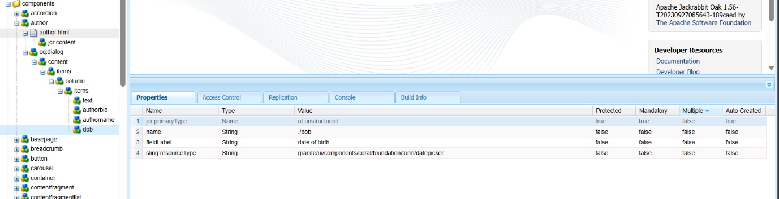

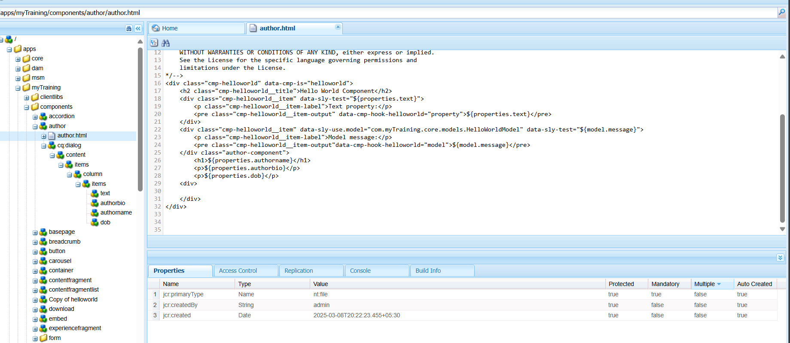

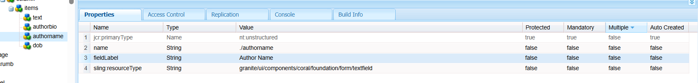

2. What is Dialog validation how to use them?

Dialog validation is used to provide additional checks before accepting a data such as using patterns to validate the user input and making sure that value is not empty

For example: 1. Adding required={Boolean} true}” in dialog field

2. Pattern based validation : validation =”{String} foundation.validation.pattern”

3. create the component with above dialog fields

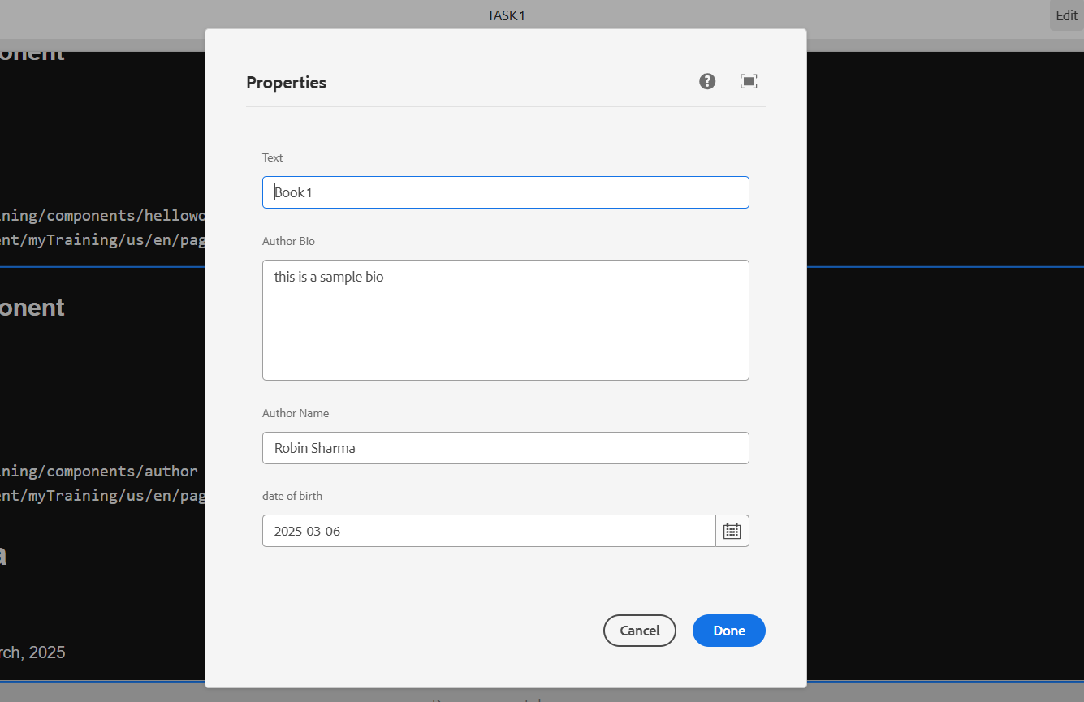

4. Fetch these value directly using htl properties tag

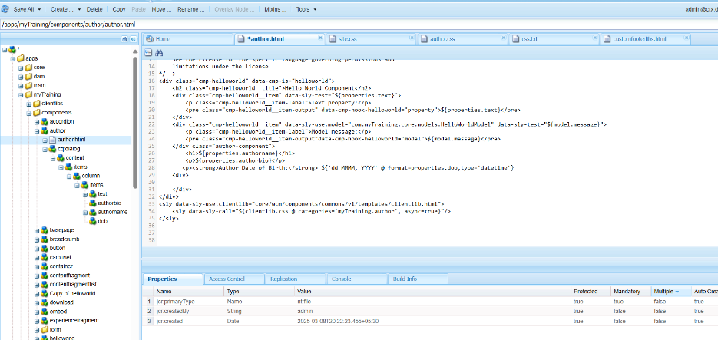

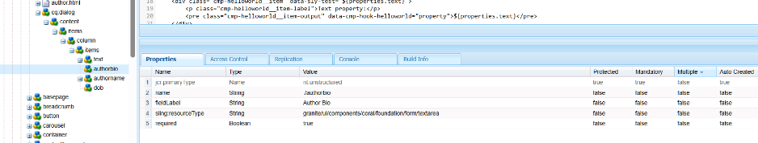

5. What is client lib?

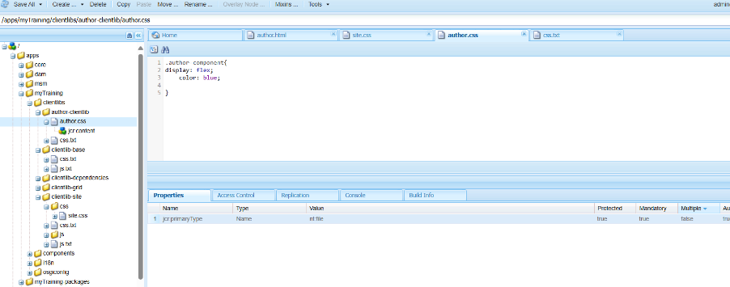

6. What is extra clientlib and how to create custom ?

It is a user defined category that helps to create additional CSS and JS . But only when needed.

